The Science Celebration registration deadline is Monday and the Open House is Thursday January 31. It is great to see so many participants registered already, but we have space for more. Science is all around us and learning about science does not necessarily require a trip to the store!
- Ice cubes and a freezing day- think greenhouse effect,
- Light bulbs and thermometer- think energy efficiency
- Black paper and Styrofoam- think insulation
- Backpacks and scale- think healthy backs?
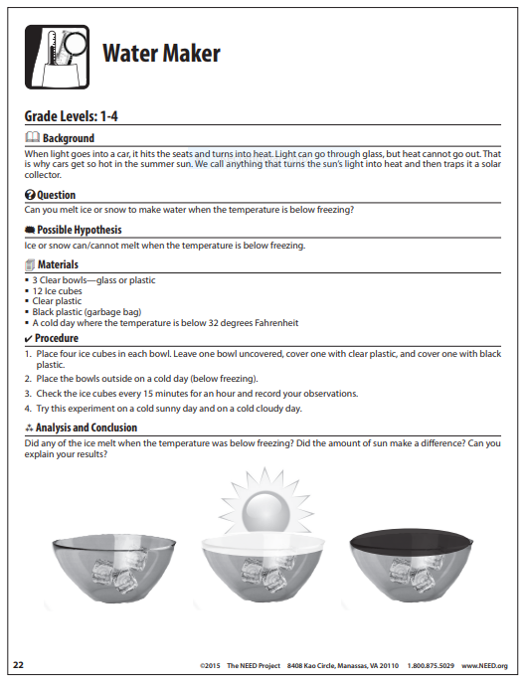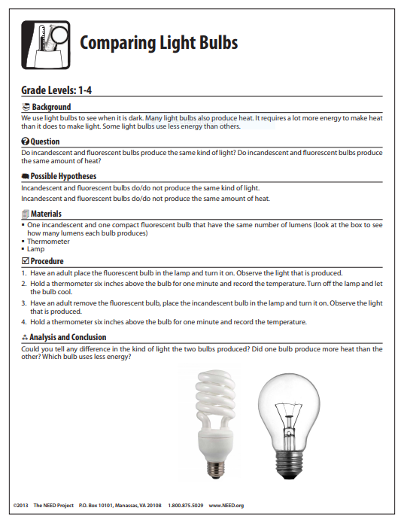
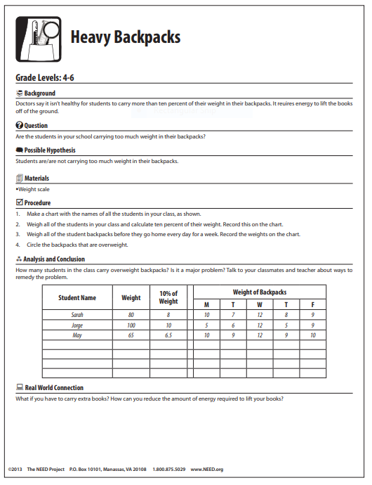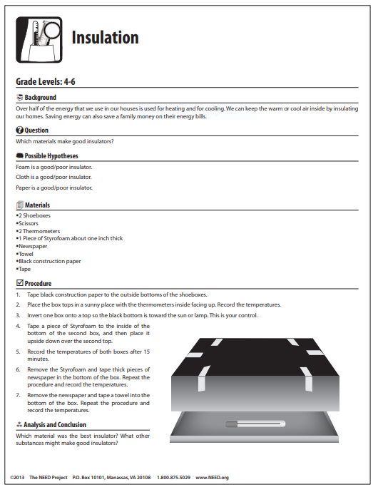
From the NEED National Energy Education Development Project https://www.need.org/sciencefair

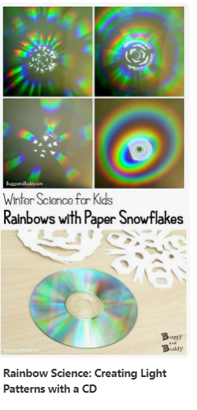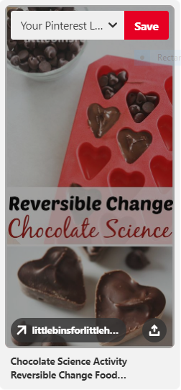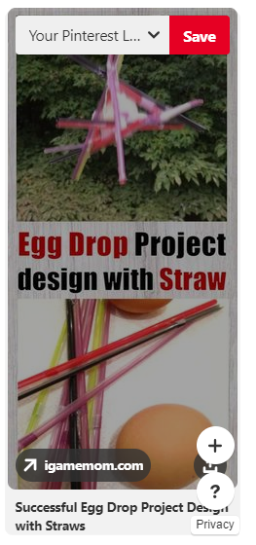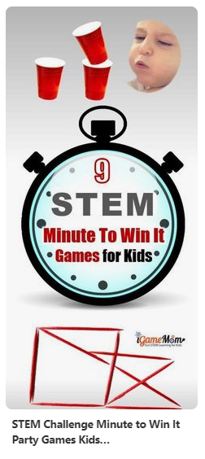
From Pinterest https://www.pinterest.com/stevespangler/science-fair-projects/?lp=true
For more information, additional topics, registration and volunteering can be found at https://eveningstreetscience.weebly.com/
Any additional questions, email sciencefair@eveningstreetpta.org

